- Open any one of your favorite websites (like Myntra, Zomato, or BookMyShow) on your mobile and desktop browser, then list 3 differences you notice in layout, navigation, or features. Explain how these differences relate to mobile-first indexing.
No. | Mobile Version | Desktop Version | Relation to Mobile-First Indexing
1 | Navigation is simplified with a compact menu, search icon, and fewer visible options. | A large navigation bar displays categories such as Men, Women, Kids, Home, etc. | Google primarily uses the mobile version of a website for indexing, so important categories and links should remain accessible on mobile.
2 | Product cards are arranged in a compact 2-column grid to fit the smaller screen. | Products are displayed in a wider grid with more products visible across the screen. | Responsive design ensures that product content remains usable and indexable regardless of screen size.
3 | Mobile focuses more on touch-friendly buttons, filters, and bottom/compact navigation. | Desktop provides more space for filters, sorting options, banners, and other controls. | Mobile-first indexing makes it important that essential content, navigation, structured data, and links available on desktop are also properly available on mobile.

- Create a simple HTML page for a 'Foodie Review' app homepage and use CSS media queries to make the navigation bar responsive for mobile screens.<br><br><em><strong>Hint:</strong> Use @media only screen and (max-width: 600px) to adjust styles for mobile.</em>
<!DOCTYPE html>
<html lang="en">
<head>
<meta charset="UTF-8">

<!-- Makes website responsive on mobile -->
<meta name="viewport" content="width=device-width, initial-scale=1.0">

<title>Foodie Review</title>

<style>
* {
margin: 0;
padding: 0;
box-sizing: border-box;
}

body {
font-family: Arial, sans-serif;
background: #f7f7f7;
color: #333;
}

/* ================= NAVBAR ================= */

.navbar {
width: 100%;
background: #e63946;
display: flex;
justify-content: space-between;
align-items: center;
padding: 15px 6%;
}

.logo {
color: white;
font-size: 25px;
font-weight: bold;
white-space: nowrap;
}

.nav-links {
display: flex;
align-items: center;
gap: 25px;
list-style: none;
}

.nav-links a {
color: white;
text-decoration: none;
font-size: 16px;
font-weight: 500;
}

.nav-links a:hover {
text-decoration: underline;
}

/* ================= HERO ================= */

.hero {
min-height: 80vh;
display: flex;
justify-content: center;
align-items: center;
text-align: center;
padding: 60px 20px;
background: white;
}

.hero-content {
width: 100%;
max-width: 800px;
}

.hero h1 {
color: #e63946;
font-size: clamp(32px, 6vw, 55px);
margin-bottom: 20px;
}

.hero p {
font-size: clamp(16px, 2vw, 20px);
line-height: 1.6;
margin-bottom: 30px;
}

.btn {
display: inline-block;
background: #e63946;
color: white;
padding: 14px 28px;
border-radius: 6px;
text-decoration: none;
font-weight: bold;
transition: 0.3s;
}

.btn:hover {
background: #c92f3b;
}

/* ================= FEATURES ================= */

.features {
display: grid;
grid-template-columns: repeat(3, 1fr);
gap: 25px;
padding: 60px 6%;
}

.card {
background: white;
padding: 30px 20px;
text-align: center;
border-radius: 10px;
box-shadow: 0 4px 15px rgba(0,0,0,0.08);
}

.card h2 {
color: #e63946;
margin-bottom: 10px;
}

.card p {
line-height: 1.5;
}

/* ================= TABLET ================= */

@media only screen and (max-width: 900px) {

.navbar {
padding: 15px 4%;
}

.nav-links {
gap: 15px;
}

.features {
grid-template-columns: repeat(2, 1fr);
}
}

/* ================= MOBILE ================= */

@media only screen and (max-width: 600px) {

.navbar {
flex-direction: column;
gap: 15px;
padding: 18px 20px;
}

.logo {
font-size: 22px;
}

.nav-links {
width: 100%;
flex-direction: column;
gap: 0;
}

.nav-links li {
width: 100%;
text-align: center;
}

.nav-links a {
display: block;
width: 100%;
padding: 10px;
}

.hero {
min-height: 65vh;
padding: 50px 20px;
}

.hero h1 {
font-size: 34px;
}

.hero p {
font-size: 16px;
}

.btn {
width: 100%;
max-width: 280px;
}

.features {
grid-template-columns: 1fr;
padding: 40px 20px;
}

.card {
padding: 25px 18px;
}
}
</style>
</head>

<body>

<!-- NAVIGATION -->
<nav class="navbar">

<div class="logo">
🍴 Foodie Review
</div>

<ul class="nav-links">
<li><a href="#">Home</a></li>
<li><a href="#">Restaurants</a></li>
<li><a href="#">Reviews</a></li>
<li><a href="#">About</a></li>
<li><a href="#">Contact</a></li>
</ul>

</nav>

<!-- HERO SECTION -->
<section class="hero">

<div class="hero-content">

<h1>Discover Great Food</h1>

<p>
Read honest reviews, discover popular restaurants,
and find delicious food near you.
</p>

<a href="#" class="btn">
Explore Restaurants
</a>

</div>

</section>

<!-- FEATURES -->
<section class="features">

<div class="card">
<h2>🍕 Best Restaurants</h2>
<p>
Discover highly-rated restaurants and
trending food places.
</p>
</div>

<div class="card">
<h2>⭐ Real Reviews</h2>
<p>
Read genuine reviews from food lovers
before you visit.
</p>
</div>

<div class="card">
<h2>📍 Find Nearby</h2>
<p>
Easily discover great food and restaurants
near your location.
</p>
</div>

</section>

</body>
</html>
The important part
@media only screen and (max-width: 600px) {
.navbar {
flex-direction: column;
}

.nav-links {
flex-direction: column;
}
}
- Use Google's Mobile-Friendly Test tool to analyze any one page from a popular Indian app website (like IRCTC, Flipkart, or Paytm). Take a screenshot of the results and list 2 mobile usability issues reported.
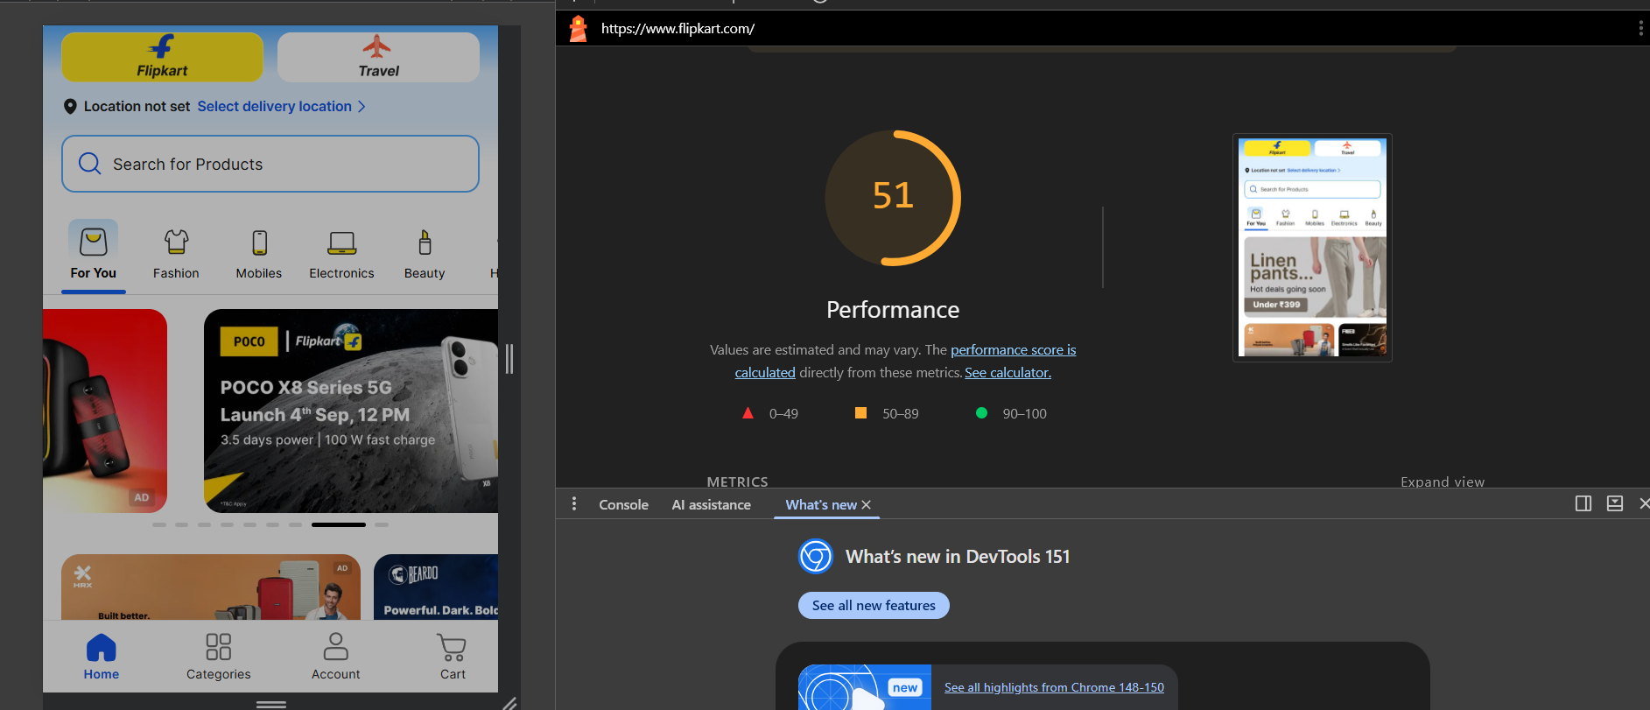
- Implement a basic Accelerated Mobile Page (AMP) version of a 'Movie Ticket Booking' landing page with AMP HTML boilerplate and one image. Validate your AMP page using the official AMP validator.<br><br><em><strong>Hint:</strong> Use https://validator.ampproject.org/ to check your code.</em>
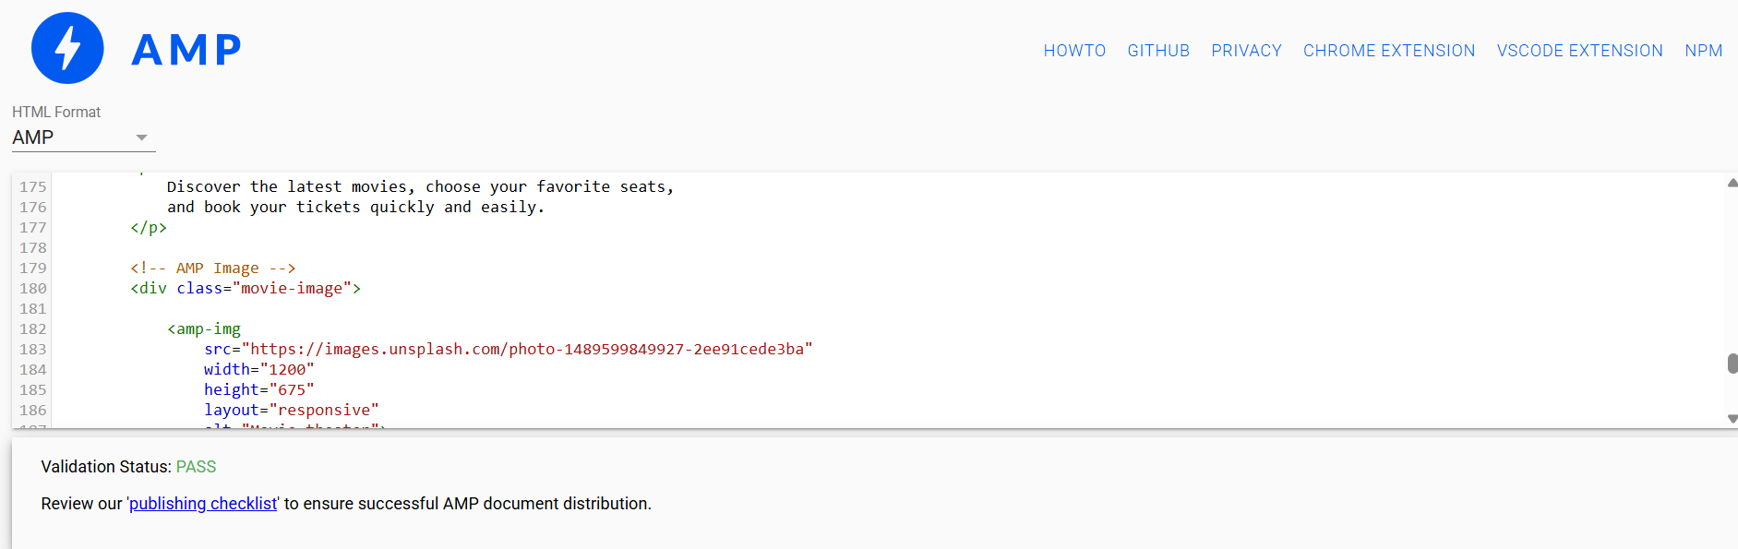

- Download a standard mobile optimization checklist from a trusted SEO blog or resource, then review your own portfolio site (or any small site you manage) against this checklist and write down 3 specific improvements you could make for better mobile SEO.
Checklist item | Current situation | Improvement
Mobile-friendly design | Some sections have large spacing and the navigation is not ideal on small screens. | Make the layout fully responsive using CSS media queries and ensure buttons/navigation are easy to tap.
Page speed / Core Web Vitals | Large images can make the homepage load slowly on mobile. | Compress images, use modern formats such as WebP, lazy-load below-the-fold images, and reduce unnecessary CSS/JavaScript. Ahrefs specifically recommends image optimization and improving Core Web Vitals.
Image optimization | Some portfolio images are larger than necessary and may not have descriptive alt text. | Resize/compress images and add descriptive alt attributes, e.g. alt="Digital marketing campaign project". Ahrefs recommends descriptive image names and alt text.

